<https://codepen.io/Paulneitor/pen/bOoPxp>

<https://huemint.com/website-1/> #ff254e #ff254e #ff254e



#db0306 #1a2b63 #fefffe

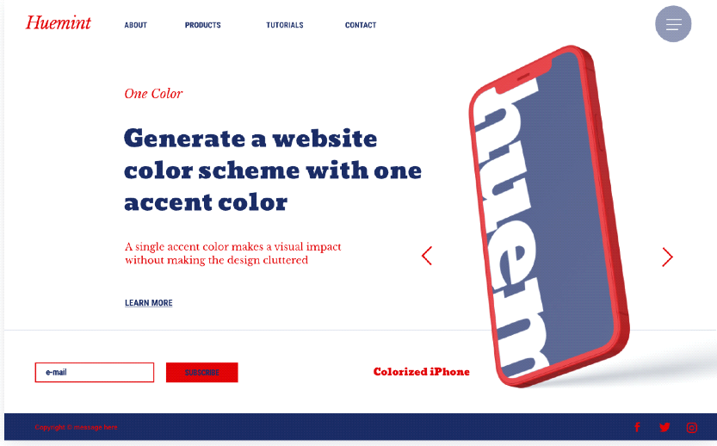

#625d55#fbd829#363c42



#4e987d #4e987d #4e987d



#e32b6b #faf5f6 #0e1e40 dark3

